SERVICES OF WORSHIP

Rockhampton South Parish

SUNDAY, MAY 5, 2013

8.00am Bushley Mrs Dorothy Demack
8.00am South R’ton Rev Glenn Ingram (HC)
9.30am South R’ton Rev Glenn Ingram
10.00am Mt Morgan Mrs Dorothy Demack
7.30pm South R’ton Rev Glenn Ingram

Thursday, May 9
10.30am Gracemere Aged Care Facility, Gracemere Gardens –
Rev Glenn Ingram

Ministers: Rev Glenn Ingram 4922 1882
Email: ingram@dovenetq.net.au

Rev Jennifer Roberts 0413 434 480
Email: strebor7@bigpond.com

Blue Care Gracemere Aged Care Facility Chaplain: Rev Glenn Ingram 4922 1882 / 0419 689 087

Hospital Chaplain: Ms Sue Dunlop 0487 604 443

Parish Office: Postal address: PO Box 8028, Allenstown Q 4700
Phone 4922 6414 Email: rockysth@tpg.com.au
Office Secretary: Lyn Thomasson

LECTIONARY READINGS

April 28 May 5
Easter 5 Easter 6
Acts 11:1-18 Acts 16:9-15
Psalm 148 Psalm 67
Revelation 21:1-6 Revelation 21:10,22-22:5
John 13:31-35 John 14:23-29 or John 5:1-9
White White

Sunday, The Fifth Sunday

April 28, 2013 in Easter

The Uniting Church in Australia

The Parish of Rockhampton South
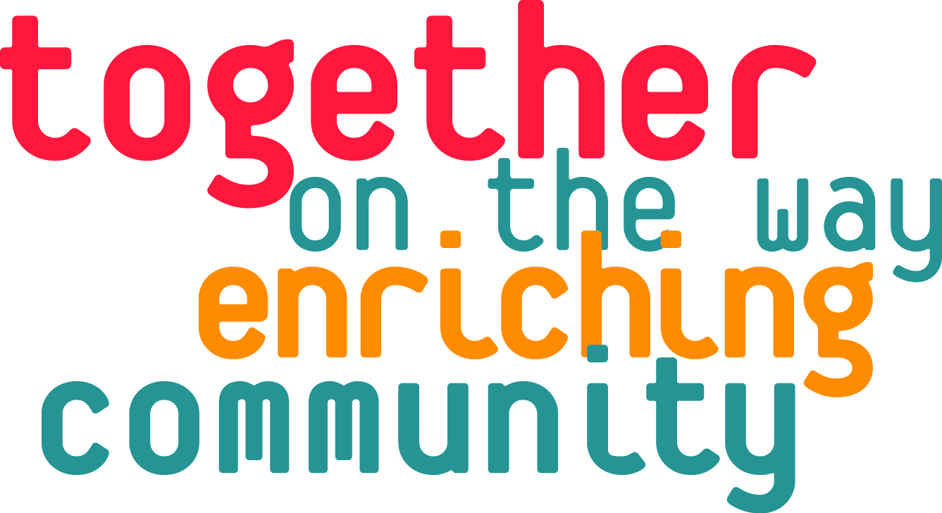
-NEWSLETTER-



MOVING WITH GOD’S SPIRIT

OUR PARISH MISSION STATEMENT

Seeking to be an active expression of God’s love in Christ to all people, both within the Rockhampton South Parish and beyond.

Our Gospel reading today, John 13:31-35, reminds us that the death of Jesus which Judas has gone to arrange will reveal the essential nature of both the Father and the Son as holy love. It is a love which is not withdrawn because Jesus and his works are rejected as blasphemy. This is the kind of love the disciples of Jesus have for one another and by which their discipleship is made known to the people in the places where they live and work. This is not the kind of love which comes easily to us who prefer to love those with whom we agree or from whom we gain a benefit.

Daily Psalm: Psalm 67: “May God’s way be known on earth.”

Daily Scripture Readings: “Blessed are those who hear the word of God and obey it -“

Mon: John 14:23-29: constantly recalling the close relationship between our love of Jesus and the keeping of his word which the Holy Spirit brought to the minds of the disciples after Jesus’ death.

Tues: Acts 16: 9-15: rejoicing that God called Paul and his companions to proclaim the good news in Europe.

Wed: Revelation 21:10,22-22:5: working tirelessly towards the time when the nations of the world will live at peace under the sovereignty of God and of the Lamb.

Thurs: Colossians 3:18-4:1: supporting those who strive to make every family a place of mutual love and every workplace a centre of mutual respect.

Fri: Colossians 4:2-6: praying for those who have received the apostles’ responsibility of evangelisation that they may reveal the good news clearly.

Sat: Colossians 4:7-18: thankful for the many men and women who were co-workers with Paul and helped spread his teachings about the Christian faith.

We extend a warm welcome to any visitors or newcomers
Welcome
with us today. Please give us an opportunity to get to know
you after the Service.
Tuesday, April 30
9.15am Play Group in the small hall – General Play.
9.30am Indoor Bowls in the large hall – all welcome.

Wednesday, May 1
9.00am Adult Fellowship Croquet Morning.(please see separate notice).
7.00pm Stillness & Meditation in the South R’ton Church with Rev Jennifer.
7.00pm Indoor Bowls in the large hall – club night.

Thursday, May 2
10.30am Gracemere Aged Care Facility, Gracemere Gardens, Combined Service – Rev Glenn Ingram.
4.30pm Prayer Time at Ingram’s, Bishop Street. All are welcome to attend.
5.15pm Worship Band practice in the South R’ton UC.
7.30pm Choir Practice in South R’ton Church.

Thank You - LENT EVENT 2013

Many thanks to all who were involved in Lent Event 2013 – through Study Groups, using the Study Book “Led by the Spirit” and/or making your donation to the 6 Overseas Projects

To date we have banked $1,757.80 into UnitingWorld’s Bank Account to go toward the 6 Overseas Projects that were highlighted during Lent this year. This is a wonderful effort considering the other Disaster Appeals made during this period.

Thank you so much for your support.

Kath Hooper & Deb Soanes
Lent Event Coordinators

Sponsors for Relay for Life: Jude Nicholson is seeking sponsorship/donations in her efforts to raise awareness of cancer by participating in Relay for Life. Anyone interested in making a donation can contact her at church. Donations over $2 are tax deductible.

Rockhampton Churches’ Covenant of Prayer

Wesleyan Methodist Church, the congregation and the pastor, Rev Keith Rose, to continue to deepen their relationship with God and to have a growing connection with the local community at Lake’s Creek.

2.

For Your Diary

Sunday, May 5
5.00pm Fellowship at Gracemere followed by fellowship tea – Rev Glenn.

Tuesday, May 7
9.15am Play Group in the small hall –.Mother’s Day Craft.
9.30am Indoor Bowls at Kent Street. Proceeds to Blue Nurses – all welcome.
7.30pm Discipleship & Personal Development Committee meeting at the Campbell Street manse.

Wednesday, May 8
9.30am Blue Care Auxiliary meeting in the small hall.
7.00pm Stillness & Meditation in the South R’ton Church with Rev Jennifer.
7.00pm Indoor Bowls in the large hall – club night.

Friday, May 10
7.00pm – 9.00pm Youth Group at North R’ton.

Tuesday, May 14
7.30pm R’ton Development Committee meeting in Sagnol House.

Friday, May 17
8am – 12.30pm Blue Care Auxiliary Street Stall in East Street.

Tuesday, May 21
7.30pm Worship & Evangelism Committee meeting in Sagnol House.

Friday, May 24
7.00pm – 9.00pm Youth Group at South R’ton.

CWCI AUSTRALIA ‘Make Your Relationship Stick’
Tuesday, May 7 at 7.30pm $10 Pizza & Pop provided
Wednesday, May 8 at 9.30am $7 morning tea provided
Creche available (morning only)
at the Christian Community Church, Moores Creek Rd, North R’ton
Contact: Jenny 4934 1186 Email: rockybek@optusnet.com.au
Speaker Angela May (Teacher and Bible Speaker)

SOUTH R’TON MOWING ROSTER 04/05/2013
Malcolm Stewart

5.

DID YOU KNOW?

Eritrea has a 1151 km coastline on the western shore of the Red Sea with Sudan to the north and Djibouti to the south. Its area is 117,600 sq km, about half the size of Victoria. It has a troubled past with its western neighbour Ethiopia. It has a population of about 6 million people whose religions are Muslim, Coptic Christian, Roman Catholic and Protestant, but the number of adherents to each faith is not known.

Ethiopia is a landlocked country in Eastern Africa with an area of 1,104,300 sq km, roughly the size of New South Wales and Victoria combined. It has a population of almost 91 million people of whom 43.5% are Orthodox Christians, 33.9% Muslim, 18.6% Protestant, 2.6% traditional religions, 0.7% Catholic and 0.7% other faiths.

You are invited to

come and try CROQUET with the Adult Fellowship

Wednesday…..1st May

at the Rockhampton Croquet Green, Ann Street Extended

Morning Tea…..9am
followed by instruction and games

Come and join us …cost $8

Flat soled shoes must be worn

CAN YOU HELP? Dog-sitter needed for Amber.

We are planning to be away for three months from late June and we are looking for someone to care for our 6 year old Golden Retriever. Care could be provided in your home or our home if you wished to house-sit as well.

If interested please contact Malcolm and Robyn Stewart to discuss details 4936 1771 / 0408 361 771.

Pray for partners in prayer at Jerusalem United Church, Rev Wezi
Manda, Pastor Percy, Deaconess Josephine Kabanda, children
and staff at Orphans and Vulnerable Children Project, Mwandi,
Zambia.



4.
Prayers in response to John 13:31-35

We give thanks for –
- the calm which Jesus displayed in the last hours of his life,
- the puzzlement of the disciples,
- the challenge of the new commandment.

We pray for –
- the gift of a calm mind in times of crisis,
- determination to seek answers to the things which puzzled the disciples,
- patience to listen to the way Christians, separated from us by doctrine and practice, express their beliefs.

We give thanks for –
- Jesus’ use of the expression of endearment, “little children”,
- the encouragement we each receive in the life of our congregation,
- the importance of forgiveness in the Christian life.

We pray for –
- eyes to see the immaturity of our faith in God,
- openness to a greater involvement in “Circles of Care”,
- willingness both to seek and to offer forgiveness.

We give thanks for –
- church organisations which allow us to show love towards those in need,
- community organisations expressing the Good Samaritan approach,
- assistance to those still affected by storm, flood and fire.

We pray for –
- the preparations for the Queensland Synod, 24-28 May,
- the Uniting World Child Care Program in North Korea,
- the people and churches in Eritrea and Ethiopia.

Prayer: Jesus, Son of Man,
who persisted in loving
those who loved you not,
open our minds and hearts,
to know that this is also
the way the Father loves us,
and remove from us the prejudice and pride
which stops us from loving other Christians
as you have loved us,
for the glory of Father, Son and Holy Spirit. Amen.

3.

